Practical - 1

Aim:
Implement a function for each of following problems and count the number of steps executed/Time taken by each function on various inputs and write complexity of each function. Also draw a comparative chart. In each of the following function N will be passed by user.
- To calculate sum of 1 to N number using loop.
- To calculate sum of 1 to N number using equation.
- To calculate sum of 1 to N numbers using recursion.

Code:

#include <stdio.h>

int count_ite = 0;
int count_rec = 0;
int count_eq = 0;

int sum_i_142(int n) {
int sum = 0;
for (int i = 1; i <= n; i++) {
count_ite++;
sum += i;
}
return sum;
}

int sum_e_142(int n) {
int sum = 1;
sum = (n * (n + 1)) / 2;
count_eq++;
return sum;
}

int sum_r_142(int n) {
if (n == 0) {
count_rec++;
return 0;
}
else
if (n == 1) {
count_rec++;
return 1;
}
else {
count_rec++;
return n + sum_r_142(n - 1);
}
}

int main() {
int n;
printf("Give Me Number To Sum of Numbers from 1 to N You want Sum of: ");
scanf("%d", &n);
int result_ite = sum_i_142(n);
printf("\n------------------------------------------");
printf("\nEnroll Number: 142");
printf("\nLoop Method");
printf("\nSum of 1 to %d Number is: %d", n, result_ite);
printf("\nCount of Step of Algorithm is : %d", count_ite);
printf("\n------------------------------------------");
int result_eq = sum_e_142(n);
printf("\n------------------------------------------");
printf("\nEnroll Number: 142");
printf("\nEquation Method");
printf("\nSum of 1 to %d Number is: %d", n, result_eq);
printf("\nCount of Step of Algorithm is : %d", count_eq);
printf("\n------------------------------------------");
int result_rec = sum_r_142(n);
printf("\n------------------------------------------");
printf("\nEnroll Number: 142");
printf("\nRecursive Method");
printf("\nSum of 1 to %d Number is: %d", n, result_rec);
printf("\nCount of Step of Algorithm is : %d", count_rec);
printf("\n------------------------------------------");
return 0;
}

Output:
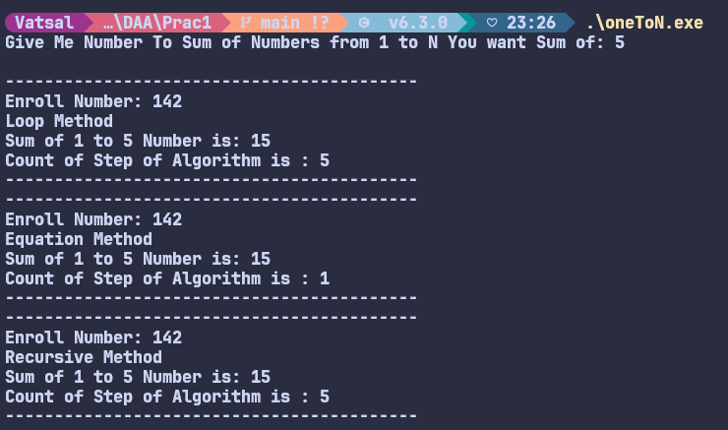

Analysis:
Value of N | Steps in iteration method | Steps in equation method | Steps in recursive method
3 | 3 | 1 | 3
5 | 5 | 1 | 5
7 | 7 | 1 | 7
10 | 10 | 1 | 10
15 | 15 | 1 | 15

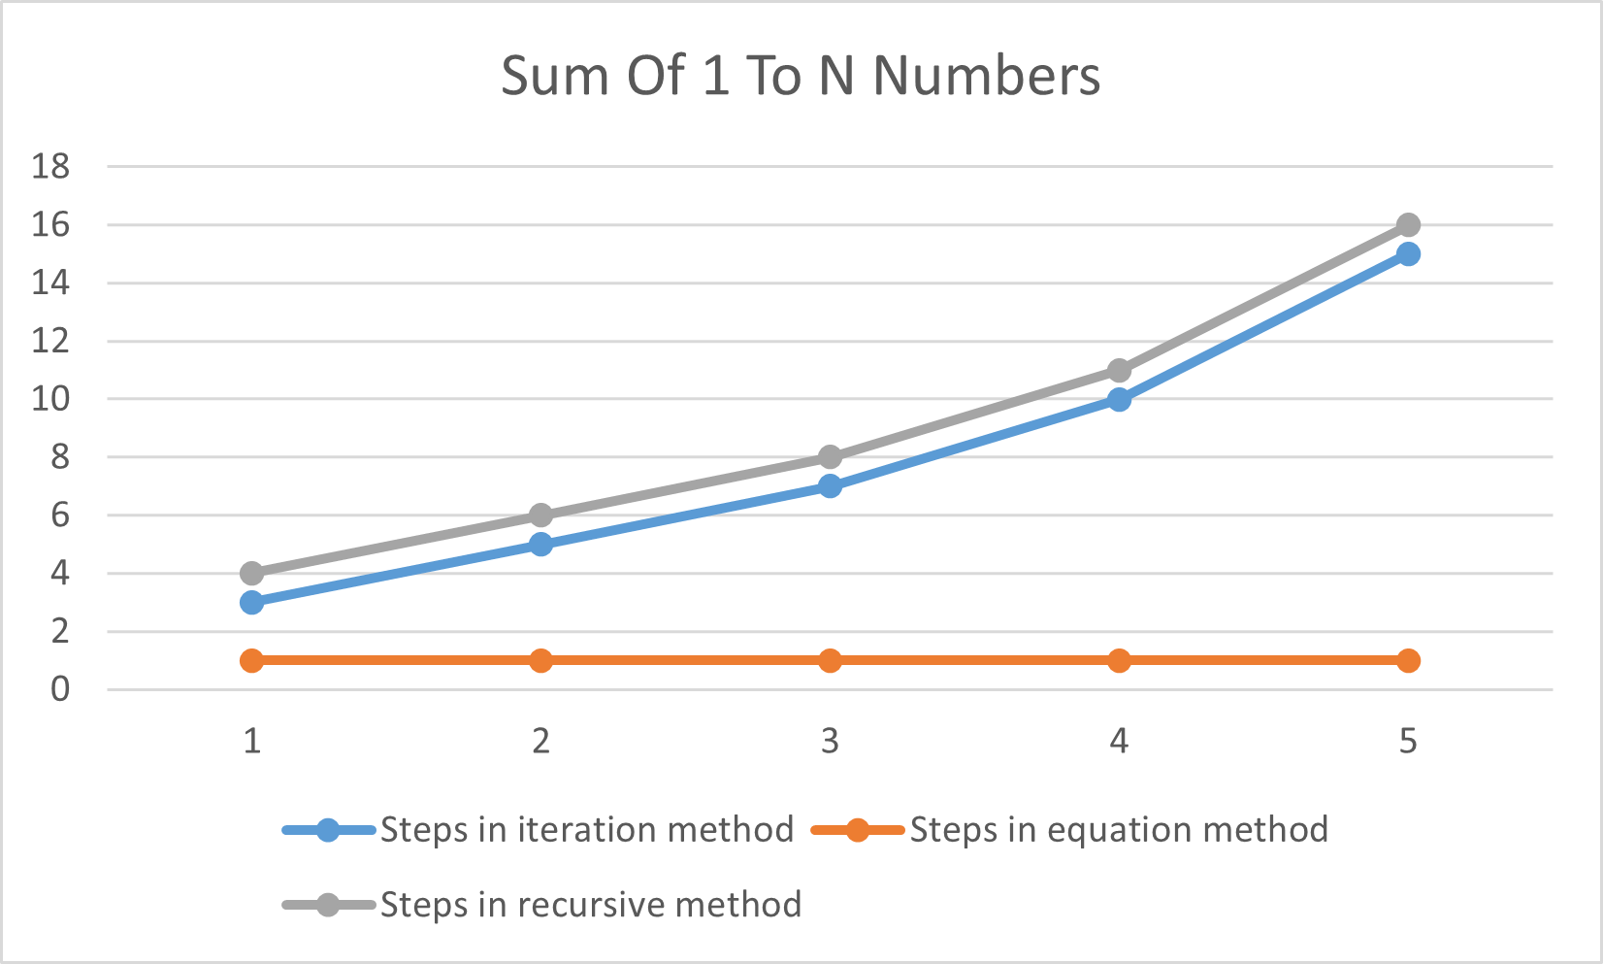

Conclusion:
- The program compares iterative, recursive, and equation-based approaches to sum 1..N.
- The equation method finishes in O(1) time with only one counted step, while the loop and recursion grow with N.
- Recursion adds overhead and risks stack depth for large N, making it least practical here.
- Iteration is predictable but still linear, so it scales poorly compared to the constant-time formula.
- Choosing closed-form or more efficient algorithms reduces both runtime and step count.
- For bigger or similar problems, prioritize algorithmic efficiency before low-level optimizations.
- Measuring step counts highlights how the right algorithm dominates performance outcomes.

